Grade Journey for eLearn Ultra (Gradebook)
- For the teaching course site
Step 3: Configure SYS/L2SYS grade column

This guide explores on how to configure the SYS and L2 SYS grade columns in eLearn Ultra Gradebook.
Note: The SYS column will be automatically provisioned by EMX 35 days before the semester ends by default. The SYS naming may vary depends on the assessment setup in EMX.
Click on the SYS column header and click Edit.

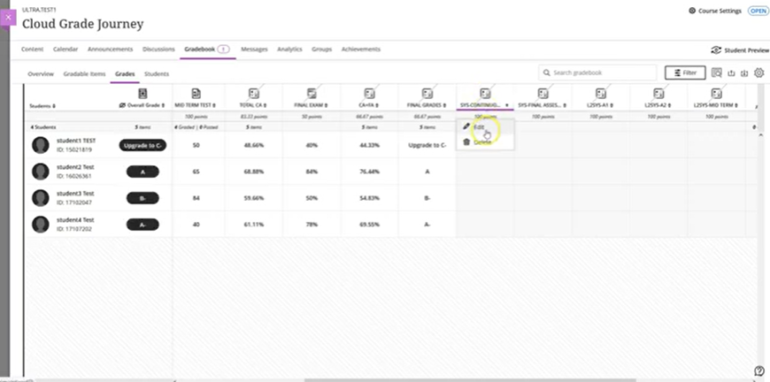
Select the gradable items you want to map from the drop-down list.
The calculation function is set to the total for the SYS calculated grade column during provisioning and shown in percentage.

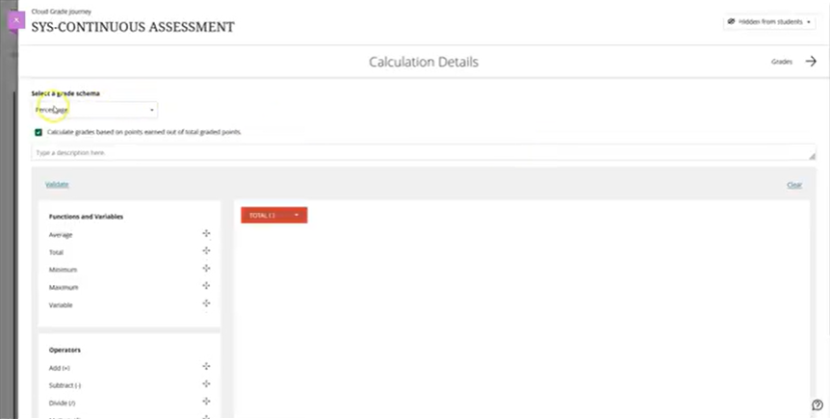

Click on the drop-down list next to the total function and select total CA from the list. Then, click Save.
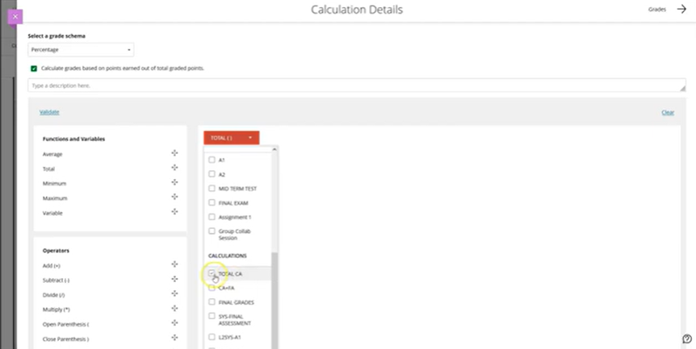

It will show a green tick if the calculation formula is correct. If the calculation expression is correct, a green tick will appear.
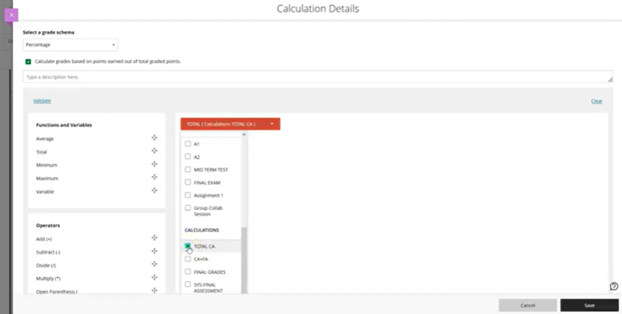
Follow the same steps to map the SYS final assessment to final assessment.
Click on the SYS column header and click Edit.
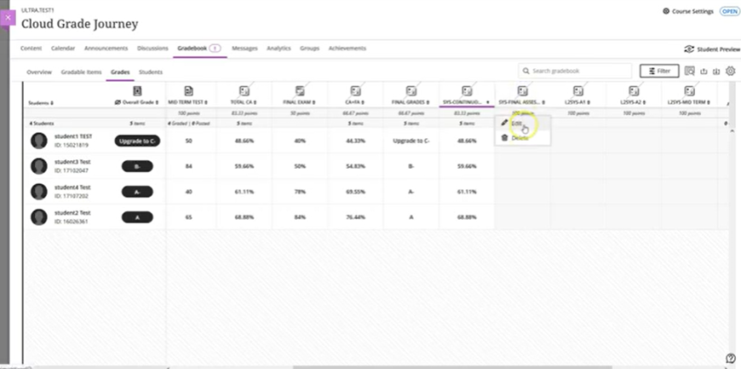

If a subject includes both coursework and exam components, two SYS columns will be created. For example, SYS continuous assessment and SYS final assessment.
Click on the drop-down list next to the total function and select total CA from the list. Then, click Save.
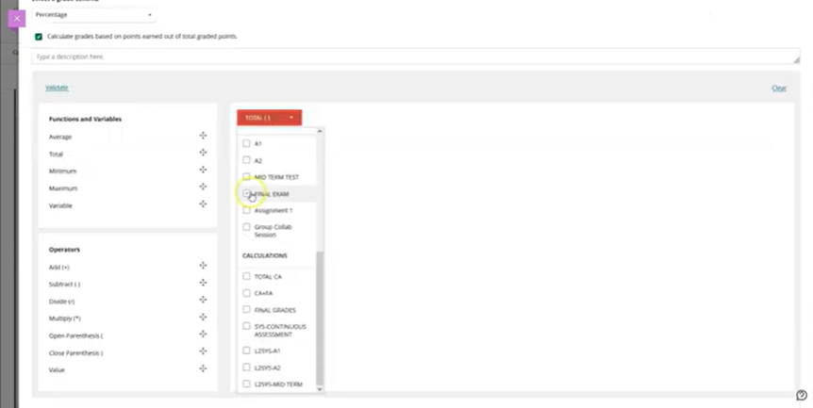
It will show a green tick if the calculation formula is correct. If the calculation expression is correct, a green tick will appear.

Please note that these SYS columns are provisioned by the system and should not be created manually or renamed. If you accidentally remove a SYS column, please submit an iDesk case to request its reprovision.

(From this point onwards, the guide will be applicable to the university programme only)

Let's configure the L2 SYS column, which is applicable only to the university programme. The L2 SYS columns are synced from IonCudos to EMX and then to eLearn.

In this example, three assessments are defined in IonCudos, A1, A2, and midterm test. Map L2 SYS columns to the corresponding assessment in eLearn. Example, L2 SYS, A1 maps to A1 grade column.

Navigate to the L2 SYS grade column header. Click Edit.

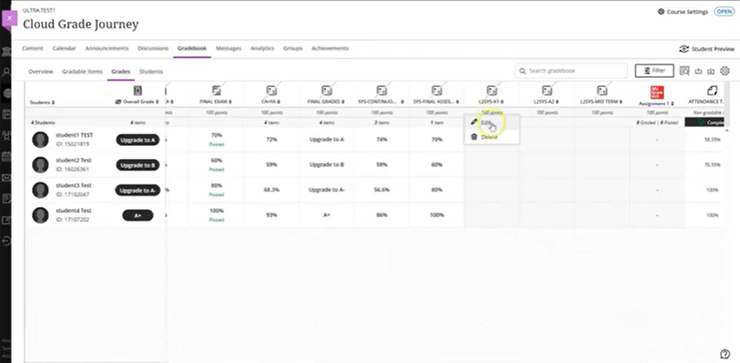

Select the gradable items you want to map from the drop-down list. Click Save.

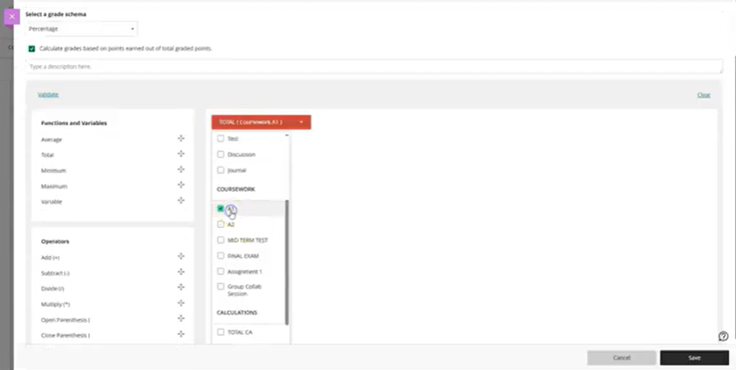

The L2 SYS column is provisioned as a calculation grade, allowing instructors to input their own calculation formula. The calculation function is set to total for the L2 SYS calculated grade column during provisioning and it must be shown in percentage.

The L2 SYS column must be provisioned by EMX and should not be renamed or manually created.
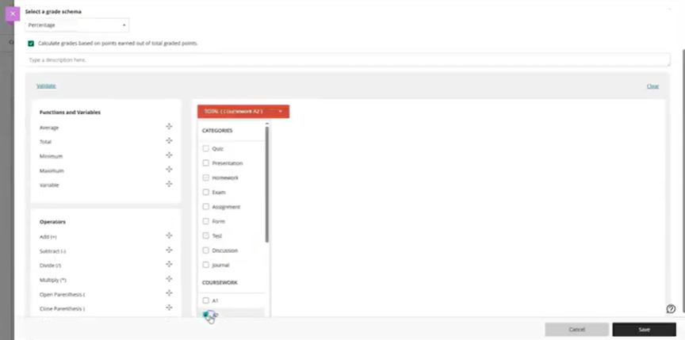

Ensure you configure the L2 SYS column before triggering the grade transfer to avoid any failures. If L2 SYS column was accidentally deleted, please raise an iDesk case to request reprovision the L2 SYS grade column.

End of Guide

